Run To Jesus – Be Cleansed
August 2026
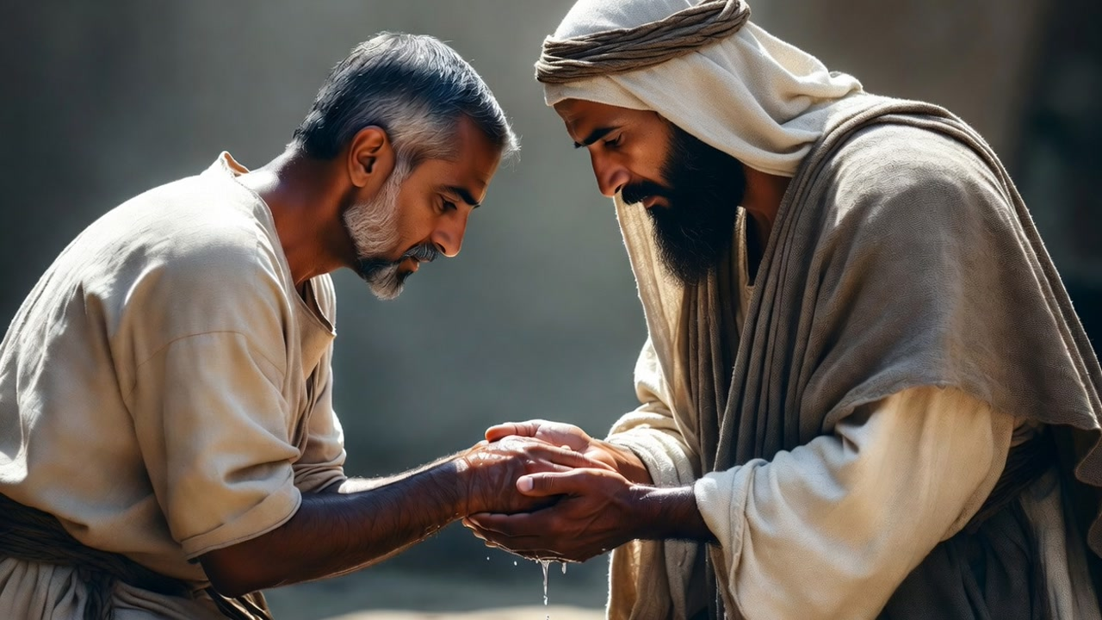
May the strength and peace of God lift you above your trial, my dear family. I know there have been many, many trials. Everything seems to go wrong. Everything happens at a bad time. We have been through the wringer. And it's a sign of the times for sure.
My beautiful family, how blessed I am to have such faithful and sweet souls on my channel.
My dear ones, I believe we are all going through an unusually intense time of trials. We've been dealing with one emergency after another. And I have to thank the Dark Crossing Channel and Jennifer LeClaire for their timely and anointed teachings that have helped us to fight back against the dark ones and regain our equilibrium with God's grace.
There's no doubt in my mind and heart that He is at the door that could open at any moment. I'm sure you all notice how intense things are getting, and there are many reasons for this. But the one that catches my attention is that some of us are doing our purgatory before the day He meets us in the air.
I believe with all my heart that when we bear these things prayerfully, accepting our correction and repenting from the heart, I believe some of the graces are used as our offering in repentance for our behavior, and others are used for dying souls who in their last moments are coming to God.
His merciful heart does not want you to suffer any more than you have. And even though we will be taken up, there is still cleansing of our souls that needs to be done. There are things He has been leading us to abandon that we have still held on to. There are attitudes, conversations, things both spoken and listened to, as well as judgments that we need to put an end to.
There are things that would never be done in heaven, which is a place of pristine purity. Anyone who walks into heaven with these attitudes will feel so awkward and out of place that they'll run and hide. That is why we must first shed this dead skin from our earth-dwelling hearts.
Yes, there's mercy, abundant mercy, but we need to have parted ways with the deadly habits of gossip, criticism, unforgiveness, and sloth. We need to have cleansed out to the very last drop everything that offends God and opposes His working in our lives to save souls.
My precious ones, we don't recognize many of the things we gloss over that offend the charity and dignity of God. The angels, too, are offended many times by our ungodly ways.
I have been asking Jesus to please reveal pride in me. He has not wasted any time. I've had many days of non-stop repentance. He's going very deep with me, and I am so glad that there is still time to repent and change my ways.
My sweet family, if we repent, He is faithful to forgive our sins. If we confess our sins, He is faithful and just and will forgive us our sins and purify us from all unrighteousness. 1 John 1:9
One thing I understand about this process is that it removes the foundation the enemy will try to build upon to bring us down. But if we humble ourselves before the mighty hand of God, no foundation is left for the enemy to devise wicked schemes against us.
And another thing is that this really does require us to repent in front of those who have seen our behavior that could have been better. We need to disclose it to them and be open that we really blew it, and that takes away the anchor that Satan would use to hook onto us to make things worse.
What I want to say is that time is shorter now than ever before. I was born when Israel became a nation in the '40s, and the Lord said that the generation born in that time "will certainly not pass away until all these things have happened." That's Matthew 24:34 and 35. Heaven and earth will pass away, but My words will never pass away.
So here I am at 80 years old, waiting for this prophecy to come about. Dearly beloved ones, some of you are of my generation, the '40s, and you're going to see the gathering together of His elect, as He later stated.
Time is up. Please prepare yourselves as deeply as you can. Don't be afraid to look at your sins and repent. Don't be afraid to make a good confession. Don't be afraid, period, unless you're afraid of not having repented and confessed your sins and been forgiven by the Lord. Then you have something to worry about.
Run into the arms of Jesus and let Him cleanse you with His and your tears mingled together. This is the time. Do not delay. He waits for you. He longs for you. He aches for you, to make you clean and ready for His hand to reach out and embrace you, flying above the chaos of the earth into your eternal dwelling.
Please cleave to Him. Sacrifice all your worldly comforts and projects to embrace Him fully and allow Him to cleanse you, for that moment is just around the corner.
Even so, when you see all these things, you know that it is near, right at the door. Truly I tell you, this generation certainly will not pass away until all these things have happened. Heaven and earth will pass away, but My words will never pass away. Matthew 24:33
The Lord bless you, dear ones, and open your hearts to the Lord to repent of those things that you haven't been able to be free of yet. And pray for us. We've been under a lot of attacks. We've had sickness. We've had technical difficulties, misunderstandings in timing and getting the messages up. I truly regret that, and I apologize to you that we've been so long between messages. We've got that straightened out now. Pray that we'll keep it straightened out.
Thank you.

